**System Analysis and Design Report**

This part of a Software Development Life Cycle model consists of all the in-depth analyses for system development including the final goal, and several functional and non-functional requirements of development. It also includes the designing diagrams to exhibit the software functioning of the product chosen along with a detailed description of the architecture of the product. The documentation contains several benefits offered by the proposed system and also the future scope and outcome of the same.

**Introduction**

The proposed product is an E-commerce website. The first question coming is What is an E-commerce system?

E-commerce systems are online facilities through websites or applications. It has the facility of both buying and selling goods through online services. The sellers provide the listing of their products including their details and pricings and manage these descriptions and any changes in them. The customers, however, access these systems to check the available products satisfying their requirements and eventually make the purchases for the same.

Both the sellers and buyers access the websites only after the verification and validations of their identities to secure the privacy of the users and ensure that there is no spam created in the system. And these systems have goods of several categories from electrical appliances to clothes, accessories, home appliances, and many more. A few of them also include grocery products.

The proposed system is an E-commerce website too and has all the features for the sellers and the buyers. It also has features for the customer supports through chatbots to solve all the queries of the users of this system.

**Benefits of the website**

An E-commerce website has several benefits that it offers to its users, such as:

1. Product finding is easier with the categorizations.
2. Products can be easily searched online and sold or brought anytime by ordering online without any headache of going out for shopping.
3. These websites offer their services round the clock and for all the days of the week without any holiday.
4. Buyers and sellers can easily reach each other without any issue of traveling the long way for the same.
5. There is no need for physical setups to the buyers that saves the cost, and for a user, it saves the cost of travelings.
6. There are a variety of sellers available for the buyers to have a wide range of choices, and this competition forces the buyers to enhance their product qualities at a reasonable rate.

These are the top benefits that an E-commerce website offers.

**Existing systems**

E-commerce websites are present in the market in a giant number, from Amazon to the Grocer, there are multiple retailing facilities offered by these services with proper home delivery for the desired products. The E-commerce market is growing tremendously, and so is the competition between several companies. These services seek millions of customers and provide services to them with quality products and on-time deliveries.

**Limitations**

However, there are several limitations associated with the existing systems in terms of management and customer care services. Many of these E-commerce services only deliver the grocery items in some specific cities, and a few of them do not include all the products. Some of these provide only clothes and accessories, while a few only offer electronic goods. Due to the lack of services offered, customers are forced to go through several of these services to buy varying categories of products.

In the case of UI/UX too, these existing services are too messy and some also have very complex navigation structures that confuse the customers. Plus, these services do not have any wallet service that can ensure the savings to be used directly for shopping. They also lack in proper categorization for many products and provide lesser product descriptions and the facts.

**Proposed System**

The proposed system has a blend of all the services that an E-commerce website offers. The product aims to meet the security and control methods along with the management of different categories of the products offered for online deliveries.

**Benefits:**

There are manybenefits of the proposed system over the existing ones such as:

1. It has a proper category-wise distribution, and the UI is pretty simple with interactive behavior.
2. For a beginner, the website also offers an interactive description of the working of the website.
3. The system is secure with a password secure database that contains the user details.
4. The system has a detailed description of each product provided, including all the facts about the same.
5. The system also offers grocery deliveries with higher accessibility.
6. Proper chat bat integration is provided for the customer support service.
7. This product will be a complete package of all the goods with their accessibilities to everyone.
8. Navigation through the system too is simpler due to the proper classification of the products.
9. It is user-friendly as well as admin friendly and effective.

**Goal:**

The goal of the product is to connect the customers accessing the customer module to the sellers accessing the admin modules. It also aims to provide an easier service that can be used by anyone and has a wide category of products to save users’ time in surfing several websites

**Functional and non-functional requirements**

The development of the desired product requires several functional and non-functional requirements along with the software and hardware requirements.

**Functional Requirements-**

These are the functions of a system’s software or components, and a function is a specification that displays the relationship between the input and output components. It specifies the system’s capability to complete the user news and requirements. A functional requirement is used to enhance the quality of the desired systems. The proposed product has the following functional requirements:

1. **Handling transactions -** The website will be able to efficiently handle all the transactions between the users and the admins, and the payment options will be highly secured.
2. **Validation -** The system will be able to do the proper validations before registering a user.
3. **Verification -** The user data will be checked with the database before providing access to the accounts, each time they try to log in.
4. **Rules in product adding -** The admins will only be able to add the products to their lists after following the business rules and providing all the facts and descriptions of the product.

**Non-Functional Requirements-**

The non-functional requirements are used for judging the performance and criteria of operations of the proposed systems. This system proposed in the documentation exhibits the following non-functional requirements:

1. **Performance -** The website will have a better performance than the other similar systems as it will have a loading time of only 3-4 milliseconds, and it will be dynamic to enhance the quality service.
2. **Scalability -** This system will also be able to handle many accounts at a time without the site getting crashed.
3. **Availability -** This is a website application that ensures its better usage at most of the devices.
4. **Usability -** The system’s interface is properly classified with multiple categories and subcategories that ensures its higher usage by most of the folks across the globe.
5. **Security -** Several encryptions, validations, and verifications are included in the system to enhance security and ensure the users’ privacy.

**Model used**

The development of this system used the waterfall model that is a sequential one for any project development. The waterfall model is the perfect suited as it follows a manner for achieving the final goals. It moves on to the next level only after the completion of the previous ones. During SDLC, each step of the waterfall model is used for several phases to help achieve the desired results without creating any mess as it is sequential. The set of steps followed by the waterfall model in SDLC are as follows:

1. Requirement gathering and analysis
2. System Design and modeling
3. Coding and implementation
4. System testing
5. Deployment of system
6. System maintenance

It is the best choice for the desired system as it has all the requirements specified pre-development, and there are no changes to be made in developing the same.

**Modules and features of the system**

The proposed system has two different login panels for users as well as the sellers (named as admin panel). The panels have similar ***modules*** that are:

1. Login/ Signup page
2. Home page
3. User/ Admin detail page
4. Orders checking page

For the admin panel, the other modules are:

1. Product listing
2. Product description page
3. Product adding page

For the user panel, the modules present are:

1. Product page
2. Add favorite page
3. Cart page
4. Product description adding page

The system proposed for E-commerce website has several ***features*** that are ensured for all the people accessing the website including both the users and the admins, that are:

1. Search for products
2. Categories for different products and their subcategories based on specifications.
3. Help service
4. Customer care service
5. Signup/ Login
6. Advertisements for new products and categories.
7. Recommendations based on previous searches.
8. User reviews and admin descriptions.
9. Blogs on new releases and add-on
10. Gift cards and coupons for users based on their purchases and for admins based on the services provided.
11. Tracking details

These modules and features make the system the best choice with the number of satisfactory services and pages provided. Also, these help to attract more users according to several surveys, as these are the basic user/ admin needs.

**Architecture and working of the system**

**Admin Panel:**

The proposed system will have the following architecture working for the admins:

*Login/Signup -> Home Page(product categories) -> Product Listing page -> Product Adding page -> Product Description page -> Check the orders Page.*

**User Panel:**

The proposed system will have the following architecture working for the users:

*Login/Signup -> Home Page (product categories) -> Product Page -> Product description page -> Favorite Page -> Cart Page -> Order checking page.*

**Working functionalities of modules:**

Here is a brief description of all the involved module-wise process involved in the whole of the system including both the admin and the user panels:

1. **Login/Signup -** This module is used for the login purpose. It has two sections, for the registered users/admins it uses the details to verify the credentials and provide access, and for the unregistered users/admins, it first validates the user details and then ensures the account access after database verifications. This section is necessary to keep the user/admin accounts secure and enhance the system’s credibility.
2. **Home Page** **-** The section has a category-wise distribution of all the available products, and a few of them also have some categories that provide the best reference to search for the desired products.
3. **Product Listing Page -** This page is accessible by the admins and it provides them a whole list of all the products offered by them. This page makes searching or editing in the products’ descriptions easier for the admins.
4. **Product Adding Page -** Here, an admin can navigate through the categories of the products available and search for the appropriate one to add another product to their list of provided products. This makes the classification of the products better as the admins only add the products to the class where it belongs to.
5. **Product Description adding Page -** After adding the product to the category, the admin uses this page to provide all the descriptions and facts related to the desired products including its material, specifications, prices, benefits, and sub-categories if present. Providing the details gets easier as it has all the questions that a user might have regarding the provided product.
6. **Product Page -** This is the page accessible by the users who want to make any purchase or add the products to their carts. This page has a listing of all the related products of the particular category and names that are provided by several admins along with their price details. This also shows a small icon image of the offered products that makes it easier for the users to select the product whose description they might want to check.
7. **Product Description Page -** This page has a detailed description of the selected product including all the specifications that the product has. It also has the price details, larger image views of the product from several angles. And also the details on any choices of materials or colors if provided by the admins.
8. **Favorite Page -** If the user likes some product and wants to save them for a later time, they may use this feature. Here, all the products that are selected by the user for later purchases are displayed, and the user can choose any ones to add to the cart whenever he/she wishes to make the purchase done.
9. **Cart page -** This page has the details of the products that the user choose for purchasing, it has the total of all the prices and the payment options choice too. Users can also add their bank/ card details in this section to be used for further purchases too.
10. **Order Tracking Page -** This page is accessible to both the users and the admins. They can check the tracking details of the orders including shipments, packagings, and deliveries. For admins, it also includes the details of all the orders provided, and for users, it includes the details of all the purchases made.

**System design**

**Data Flow Diagram (DFD) –**

DFD is a representation of data flow through a system developed. It provides details about the related outputs and inputs for each system function. These diagrams do not involve any control flow, looping, or decision statements. DFDs are of 3 types, level 0, level 1, and level 2. For the proposed system, we are going to see the level 0 and level 1 DFDs that are given below:

***LEVEL 0 DFD:***

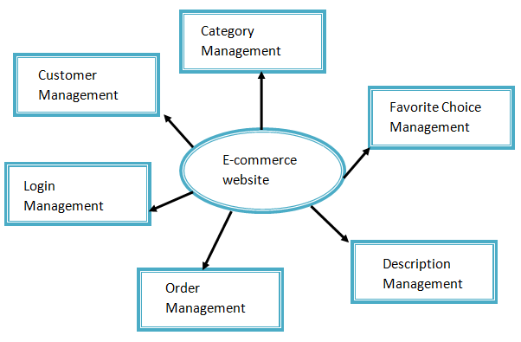

***LEVEL 1 DFD:***

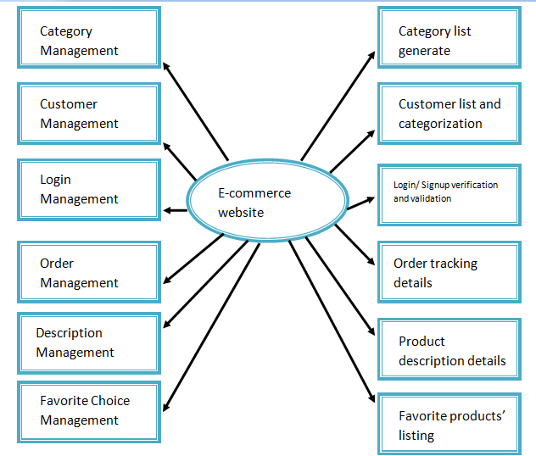

**Activity Diagram –**

The activity diagram is a graphical representation of all the activities related to several modules that are involved in the system. It is a dynamic representation to show the relationship and steps involved for navigations through the system. The proposed system has 2 different activity diagrams as follows:

**ADMIN PANEL-**

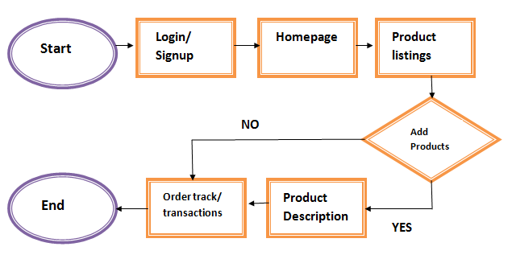

**USER PANEL-**

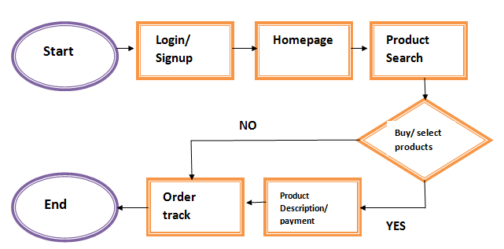

**Use Case Diagram –**

It represents the interactions of several users with the system under consideration. The diagram represents the relationship that each user has with various components of the system and how they interact with the same. For the proposed system, the use case diagram is displayed below:

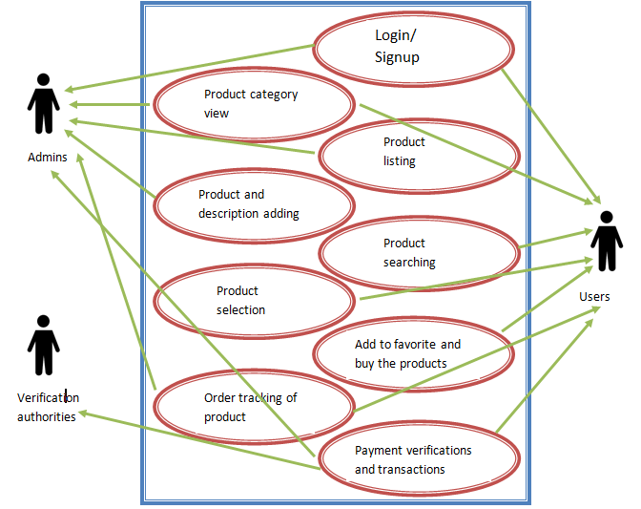

**Security and Control**

Security and control measures play a crucial role in software development. In the proposed system, special care has been taken for the security measures, and for the same, the database with several password requirements is chosen to keep the user data secure. The secure systems attract global users by respecting the privacy concerns of the users and saving them from any spams caused due to the information leakages. Keeping a system secure also helps to raise the status of the system and increase the customer’s trust towards it. After maintaining security, it is also important to control that by going for several verifications to maintain the system’s behavior and performance quality.

Several measures have been taken to ensure higher ***security and control***, which are as follows:

1. A secure database opted that has several passcode locks.
2. Verifications of data before giving access to the user accounts.
3. Proper account verifications of users to check for secure payments.
4. Option to save the website credentials via google accounts for easy accessibility and going for passcode locks for accessing them instead.
5. OTP method to check for the payments from correct accounts.

These measures will help the users stay secure and maintain their privacy, and will help the admins to get the right users and right payments from secure accounts. And eventually, it will help the system to develop its user base.

**Conclusion**

The desired product has all the specifications that are desired and satisfy all the user needs, however, there is some room for slight updates that will enhance the quality of the system more.

**Future Scope**

The system might include some added features, like:

1. Recommendation system might be added to show the users the products that they might like and want to buy.
2. A request system that any user/admin would have access to request the system to add any more product categorizations.
3. Sentimental analysis to ensure the correct product review details.

**References**

1. Ilbahar, E. and Cebi, S., 2017. Classification of design parameters for E-commerce websites: A novel fuzzy Kano approach. *Telematics and Informatics*, *34*(8), pp.1814-1825.
2. Shah, T. and Patel, S.V., 2016. A novel approach for specifying functional and non-functional requirements using rds (requirement description schema). *Procedia Computer Science*, *79*, pp.852-860.
3. Kramer, M., 2018. Best practices in systems development lifecycle: An analyses based on the waterfall model. *Review of Business & Finance Studies*, *9*(1), pp.77-84.
4. Aleryani, A.Y., 2016. Comparative Study between Data Flow Diagram and Use Case Diagram. *International Journal of Scientific and Research Publications*, *6*(3), pp.124-126.
5. Arora, P.K. and Bhatia, R., 2018. Agent-based regression test case generation using class diagram, use cases and activity diagram. *Procedia Computer Science*, *125*, pp.747-753.